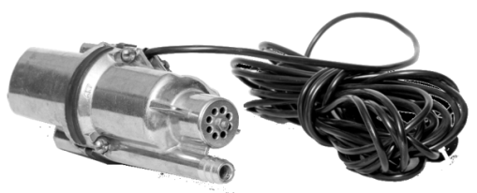

**[](http://olsa.by/ru/nagrady.html)**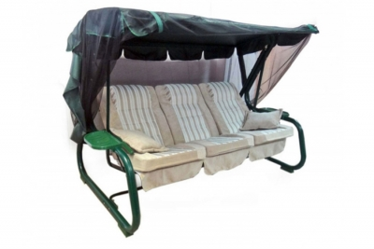

**Open Joint Stock Company "Olsa" (JSC «Olsa»)**

**23, Karl Marx Str., Mogilev, 212030, Belarus**

**fax: +10 375 (222) 22-98-89, tel. 22-10-32**

[**www.olsa.by**](www.olsa.by)

Dear Sir or Madam,

JSC «Olsa» is a leader in the manufacture of garden furniture in Belarus. And we would like to offer our products for selling in your stores.

Our company produces furniture for camping, garden, terraces and houses. Also we manufacture furniture for hospitals, household pumps and small-size woodworking machines.

All products are certified.

The company operates a quality management system in accordance with the STB ISO 9001-2009.

The advantages of working with us:

- reasonable price

- wide range of products

- guaranteed quality

- packing on europallets

- timely deliveries, developed of own logistics structure

- electronic document management

- experience with IKEA and Leroy Merlin (Russia)

Furniture with the brand name «OLSA» combines European design, reliability, comfort and ease of use and allows to organize a pleasant and comfortable stay in the garden, home, villa, beach, hunting, fishing and nature.

Our products find a steady demand in Russia, Kazakhstan, Azerbaijan, Georgia and Ukraine. Our company introduces new products every year. And we are ready to offer the most interesting goods for you.

We are looking for new areas and companies for marketing of our production and long-term contracts are highly appreciated.

More information about us is available on our website [www.olsa.by](http://www.olsa.by)

Thank you in advance for your attention.

If you have any questions or concerns, don’t hesitate to let me know.

Best regards,

Eugene Pogostev

Head of the Marketing Department

[olsa_marketing@tut.by](mailto:olsa_marketing@tut.by)

Tel. +10 375 222 310496

**Vendor Profile**

|  |  |
| --- | --- |
| **GENERAL INFORMATION** | |
| **Company Name in English:** | JSC «Olsa» |
| **Company Name in local language:** | ОАО «Ольса» |
| **Form of business ownership** | Open joint stock company |
| **Address in English** | 23, Karl Marx Str., Mogilev, 212030, Belarus |
| **Website:** | www.olsa.by |
| **TIN Taxpayer identification number** | 700049597 |
| **Type of Business :** | Manufacturing |
| **Certification:** | ISO 9001-2009 |
| **Creation Date:** | in Jan. 1932, last reorganization - 14.11.2011 |
| **Size of the industrial area** | 39 sq.km |
| **FINANCIAL INFORMATION** | |
| **Bank Name :** | «BANK MOSCOW-MINSK» JSC |
| **Address :** | 37A, Pioneer Str., Mogilev, 212030, Belarus |
| **Account Number (EUR):** | 3012110790094 |
| **Date of opening :** | 24.08.2010 |
| **Shareholder Name :** | The State Property Committee of the Republic of Belarus |
| **Share%** | 97,67 |
| **MARKET & CATEGORIES INFORMATION** | |
| **Main Brand** | OLSA |
| **Main Category:** |  |
| * **Camping Furniture, incl.** | * [Garden Swings](http://olsa.by/en/all/itemlist/category/2-kacheli-sadovye.html) |
|  | * [Chairs, Chaise Lounges](http://olsa.by/en/all/itemlist/category/3-kresla-shezlongi.html) |
|  | * Guest beds and etc. |
| * [**Medical Furniture**](http://olsa.by/en/all/itemlist/category/11-medicinskaja-mebel.html) |  |
| * [**Submersible household pumps**](http://olsa.by/en/all/itemlist/category/30-nasosy-rucheek-i-rucheek-1m.html) |  |
| * [**Small-size woodworking machines**](http://olsa.by/en/all/itemlist/category/33-malogabaritnye-mds.html) |  |

|  |  |  |  |  |  |  |  |  |  |
| --- | --- | --- | --- | --- | --- | --- | --- | --- | --- |
| **Turnover** |  | **Year (N-3)2013** | | | **Year (N-2)2014** | | **Last Year (N-1) 2015** | | **This Year Estimates 2016** |
| Total Turnover | | **$34 853 300** | | | **$33 282 600** | | **$24 605 500** | | **$25 000 000** |
| Export % | | **70%** | | | **73%** | | **74%** | | **75%** |
| **Export Market** | | | | | | | |
| **Major Countries** | | | | **Turnover %** | | | |
| Russia | | | | **93%** | | | |
| Ukraine & CIS | | | | **5%** | | | |
| Other Europe | | | | **2%** | | | |
| **Main Categories and % for Last Year Turnover** | | | | | | | |
| Camping furniture | | | | | | **53,4** | |
| Submersible household pumps | | | | | | **45,0** | |
| **Main Clients** | | | **Country** | | | **%** | |
|
| Leroy Merlin | | | Russia | | | **11%** | |
| IKEA | | | Russia | | | **7%** | |
| OMA | | | Belarus | | | **5%** | |

|  |  |
| --- | --- |
| **Human Resources** | |
| **Total, Incl.** | **1065** |
| Production | 862 |
| Quality | 35 |
| R & D | 27 |
| Marketing and sales | 32 |
| **Contacts :** | |
| **Director - Nikolai Tsykunov** | tel.: +375 222  31 03 73 Fax: +375 222 22 07 96  [olsa_garden@tut.by](mailto:olsa_garden@tut.by) |
| **Key account person - Natalya Regetta** | tel.: +375 222  25 02 00 |
| **Marketing and Sales** |  |
| Head of department - Eugene Pogostev | tel.: +375 222 31 04 96 |
| Sales reps | tel. : +375 222 22 10 32 tel. : +375 222 25 01 46 Fax: +375 222 22 98 89  olsa_marketing@tut.by |